**Creating Templates**

**Introduction:**

To understand how to create a template for the Manifest Upload application there are a couple things to keep in mind. The first is that the spread sheet is read in two passes. The first pass reads the vessel information (Exporter, Departure Date, Vessel Number, Vessel Name, Destination, and Pallet Prefix). Next the data in the data range is read in with the first row being used to create the names of the columns in the data display.

**Editing or Creating Templates:**

Open the template editor. It will be found under the Tools Menu item Edit Tables as shown below

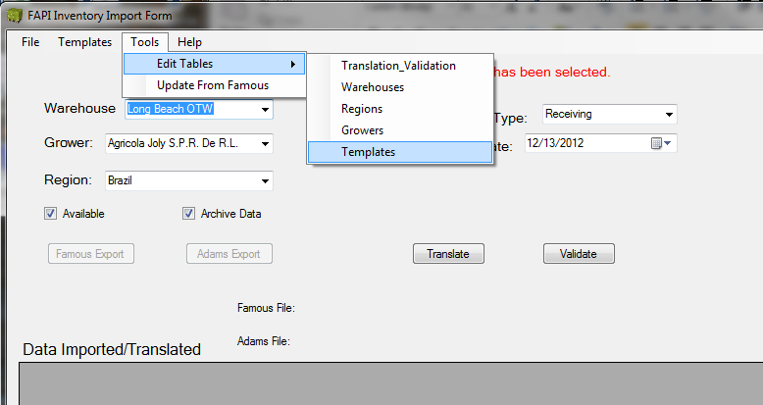

Clicking on “Templates” will open the editor as shown below.

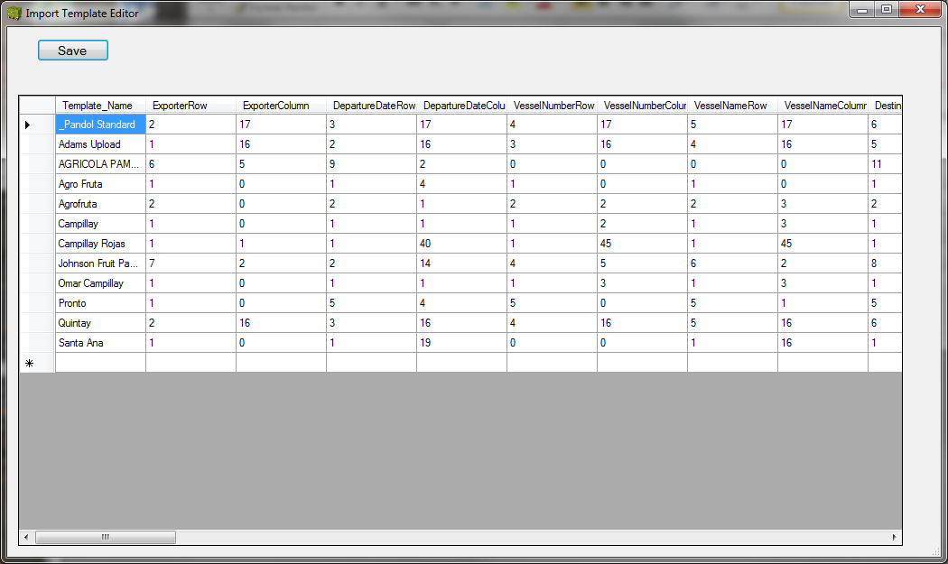

All rows and Columns start at the number 0 (Zero) and not 1 as would normal be expected. Print out a copy of the spreadsheet to create the template for. Here is a partial translation table for the letters to help.

|  |  |  |  |  |  |  |  |  |  |
| --- | --- | --- | --- | --- | --- | --- | --- | --- | --- |
| A | 0 | I | 8 | Q | 16 | Y | 24 | AG | 32 |
| B | 1 | J | 9 | R | 17 | Z | 25 | AH | 33 |
| C | 2 | K | 10 | S | 18 | AA | 26 | AI | 34 |
| D | 3 | L | 11 | T | 19 | AB | 27 | AJ | 35 |
| E | 4 | M | 12 | U | 20 | AC | 28 | AK | 36 |
| F | 5 | N | 13 | V | 21 | AD | 29 | AL | 37 |
| G | 6 | O | 14 | W | 22 | AE | 30 | AM | 38 |
| H | 7 | P | 15 | X | 23 | AF | 31 | AN | 39 |

Take the printed copy of the import spreadsheet and number the rows and columns for the following fields: Exporter, Departure Date, Vessel Number, Vessel Name, Destination and Prefix. For example in the one below, the exporter is at location 3:Q. Which would be entered as row = 2 and column = 16 for the exporter. Likewise the remaining rows and columns for the vessel information would be as follows.

Exporter - Row = 2, Column = 16

Departure Date - Row = 3, Column = 16

Vessel Number - Row = 4, Column = 16

Vessel Name - Row = 5, Column = 16

Destination - Row = 6, Column = 16

Pallet Prefix - Row = 7, Column = 16

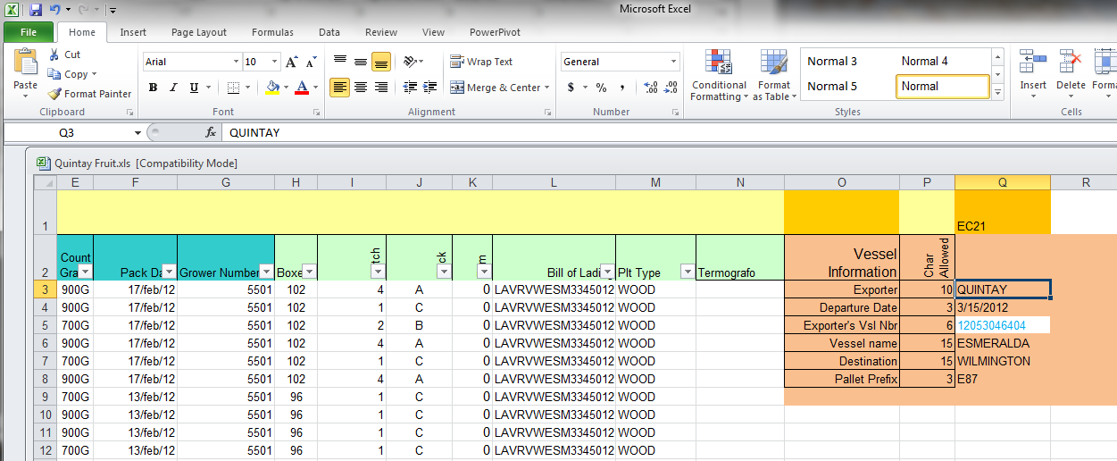

The rest gets a little more complicated. Next step is to determine where the rest of the data is in the spreadsheet. To determine the data range, first find the row that contains the column headers. In this case it row 2 in the spreadsheet. The column range goes from A to N, the vessel information in columns O to Q can be ignored as this information will have already been retrieved. The data range then will be entered as A2:N. Put this into the “Data_Range” column of the template or write it onto the template form worksheet (Paper). The data sheet will be the sheet name followed by the $. If the exporter will always use the same name enter that. If not then use “DATA$” (note the $ added to the end of the name). You will have to rename the sheet name before importing the spreadsheet however each time you get one from this particular exporter. Some inspection and cleanup may be necessary on the spreadsheets as there is no guarantee that they will always be the same.

Here is an example of this section of a filled in template with example entry highlighted.

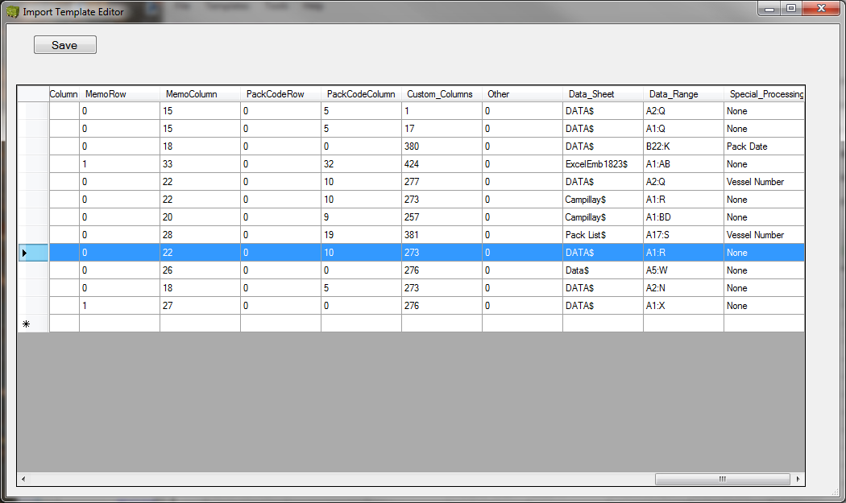

Go through and fill out the remaining fields, entering their location (start row and column) in the spreadsheet. Put a 1 in the missing column if any are missing. Note the commodity row and column location is currently are the last two columns of the template.

Custom_1 codes are determined from the table below.

|  |  |  |
| --- | --- | --- |
| Style & Size | 1 |  |
| Grade | 2 |  |
| Pallet Type | 4 |  |
| Hatch & Deck | 8 |  |
| Commodity | 16 |  |
| Fumigation | 32 |  |
| Bill of Lading | 64 |  |
| Pack Code | 128 |  |
| Memo | 256 |  |

If any of the above columns are missing, add the numbers from the above table and enter that sum into the custom_1 field; e.g. if the fumigation and bill of lading columns are missing, use 32 + 64 or 96 for the custum_1 value. With the exception of the commodity column, they will be added to the far right of the spreadsheet data. There is also a Grower Block column that is put into position 1 on all imported data.

There are also some special processing codes that are used.

Pack Date – This adds a pack date column and populates it with the ship date for manifests which do not have the pack date data.

Vessel Number – This is used when the vessel number field includes text as part of the number and the number needs to be extracted.

The “Other” field is currently not being used and should have a “0” (Zero) put in the field.

When it appears to be correct, save the changes and run the Manifest Import application. Load the template and a spreadsheet it is for. Then check the column locations in the Data view to verify that the column locations agree with what was put into the template. Verify that all missing columns are added and make corrections as needed to the column locations.